1. 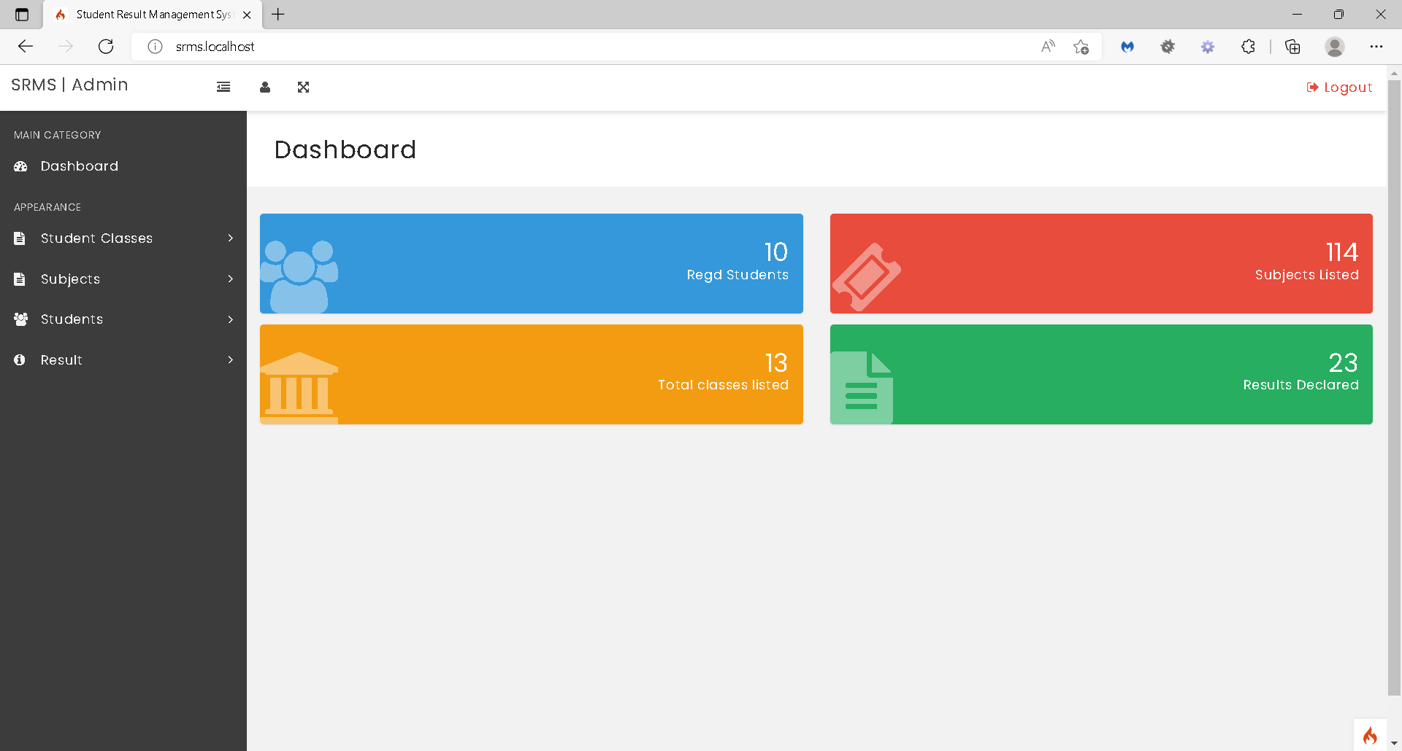Open Dashboard
2. Goto manage student subject combination

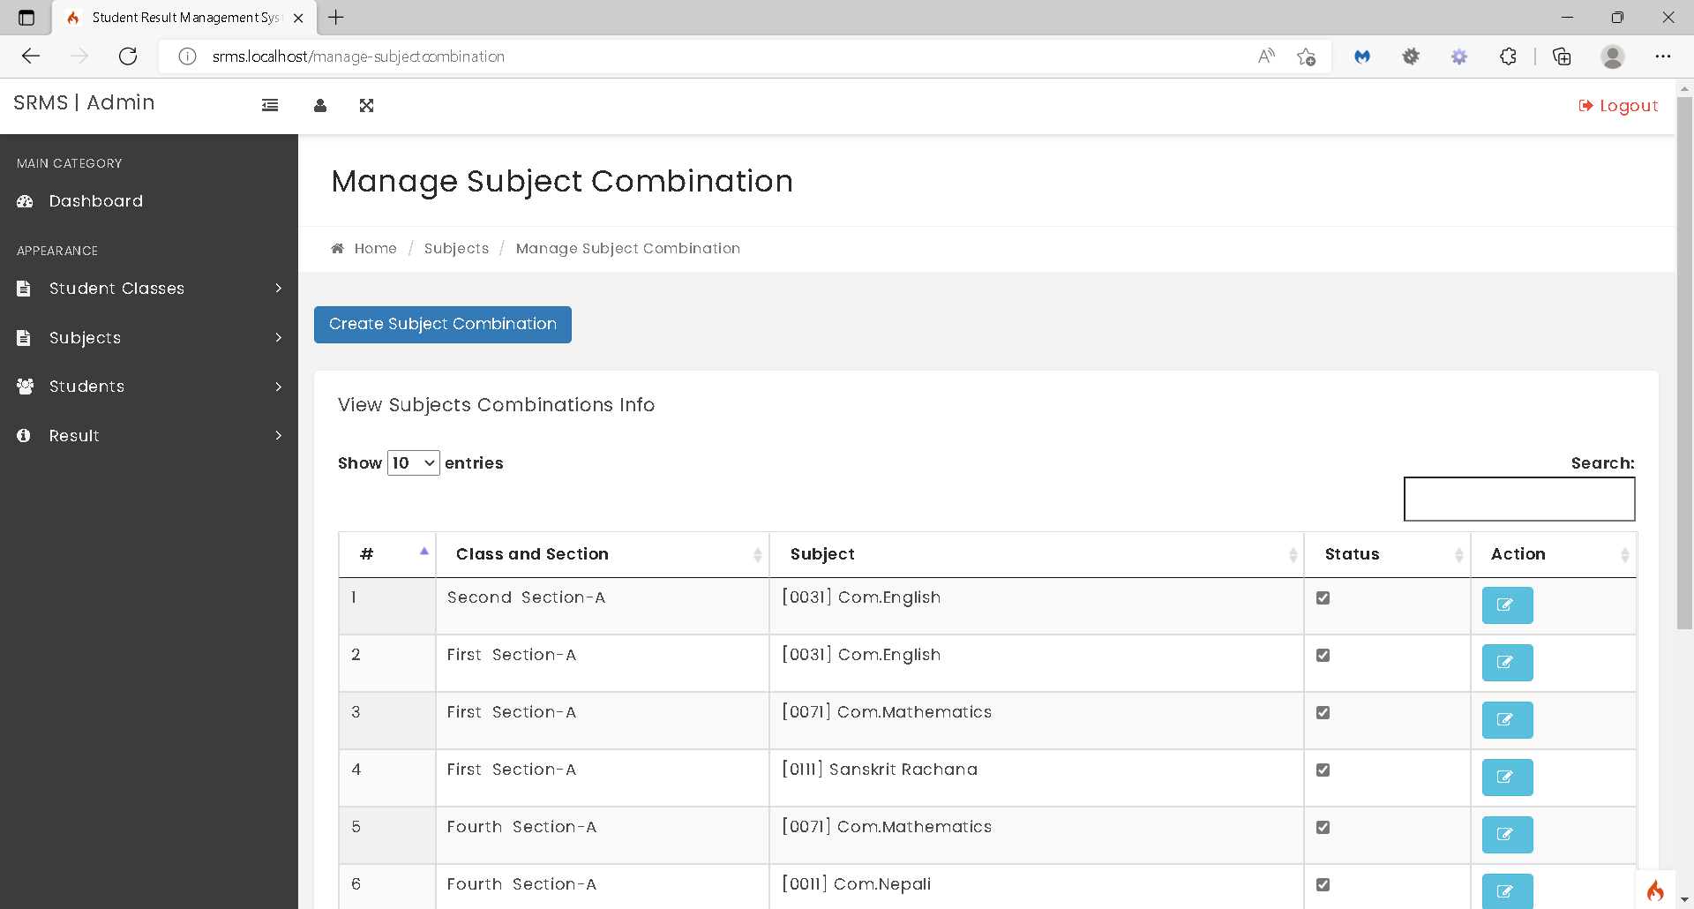

1. Create/Edit student subject combination



1. Goto Manage Students

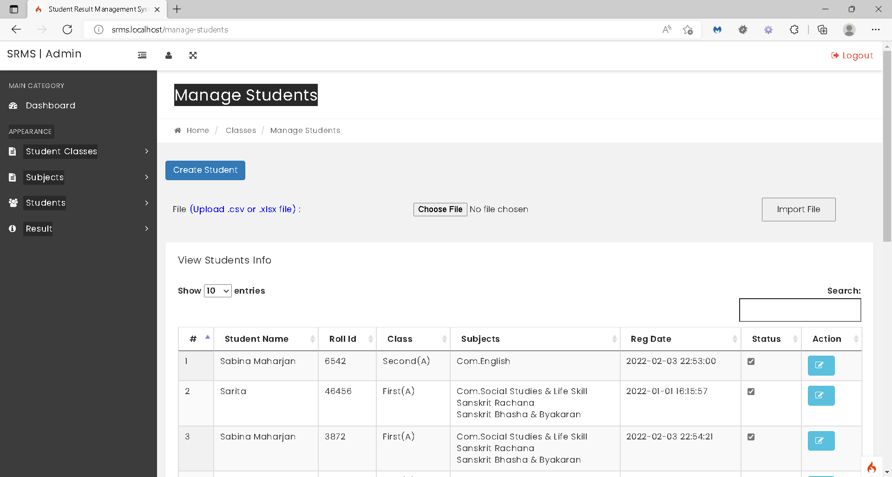

1. Create/Edit student. Select class (class and section) of the student.

